**The register page(Username: TonySong):**

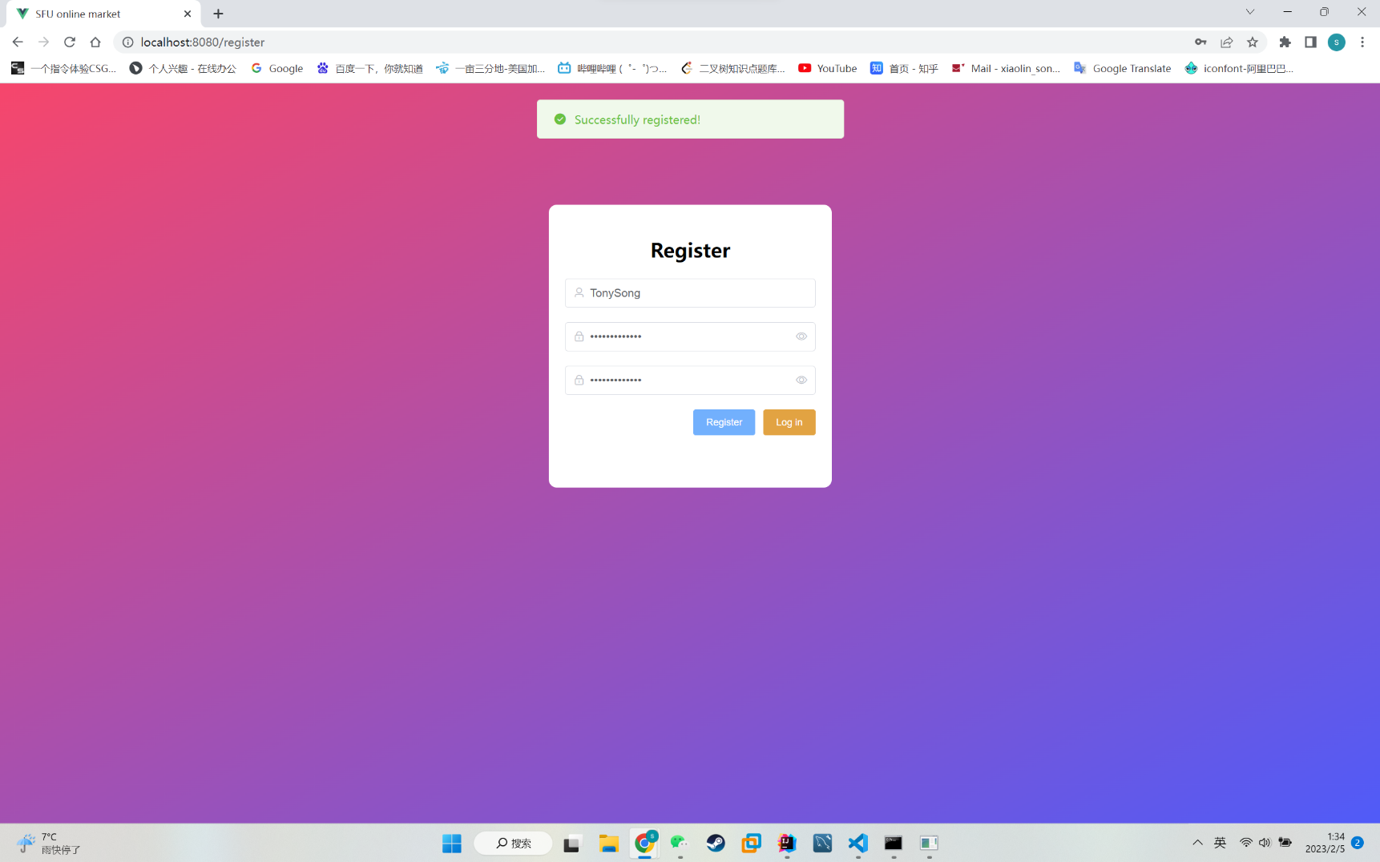

**Main page after logging in:**

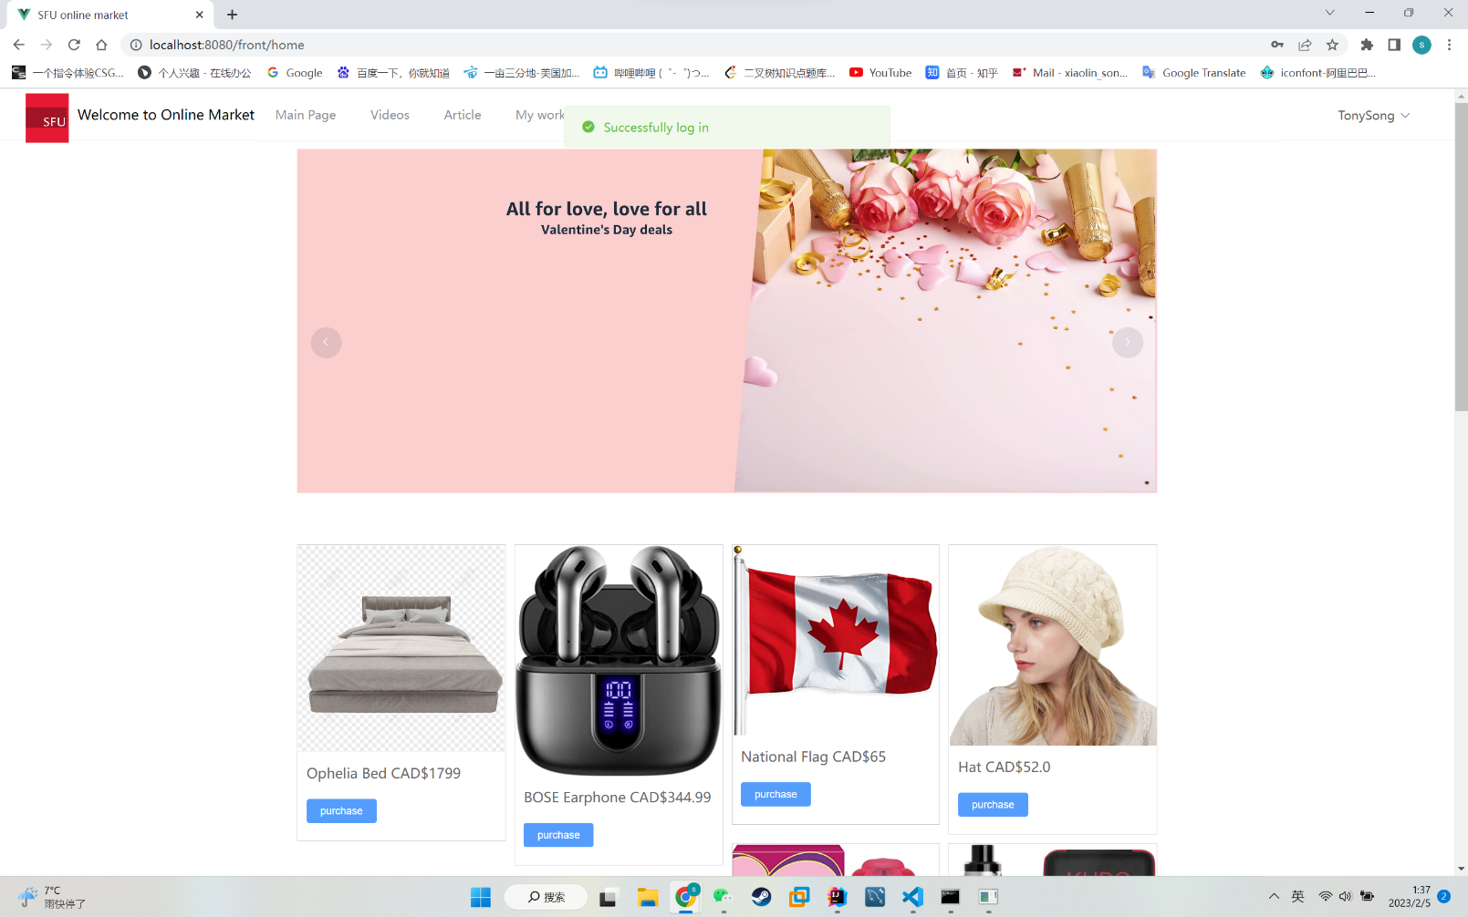

**Products and their price:**

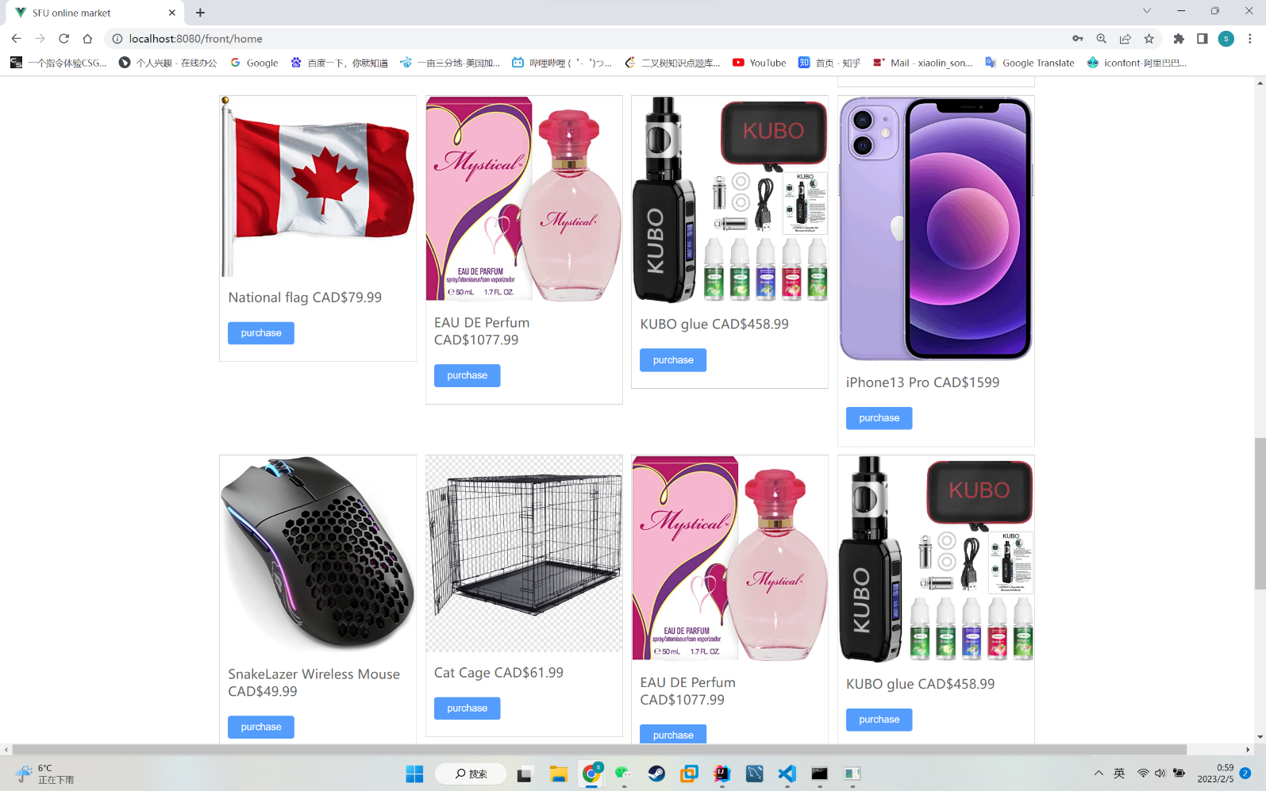

**Add further information and upload profile picture for user @TonySong:**

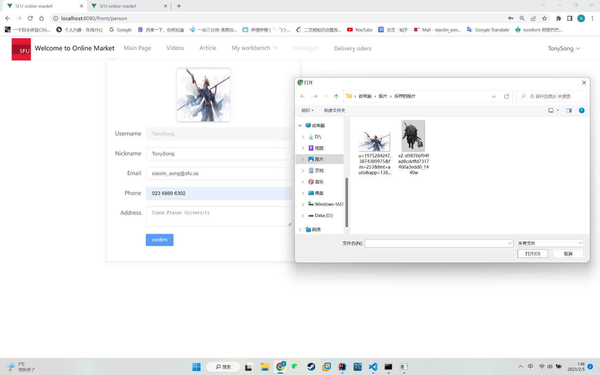

**Profile picture added successfully:**

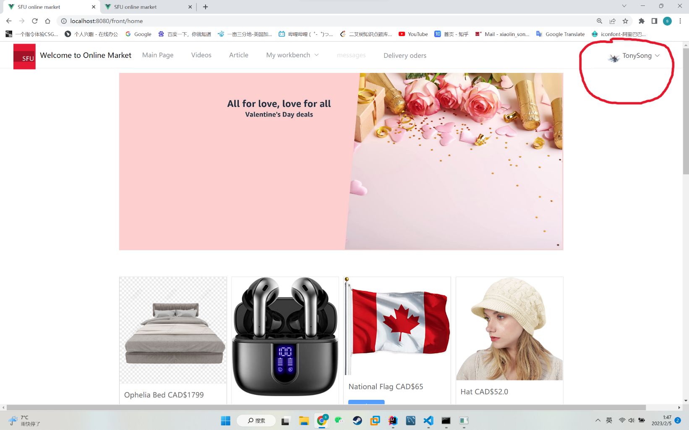

**Change password:**

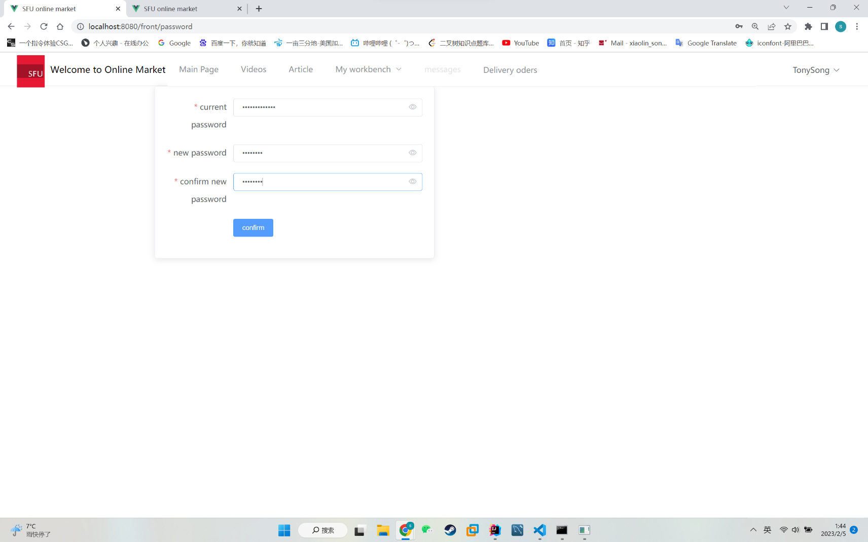

**Write two articles and upload them with TonySong as author:**

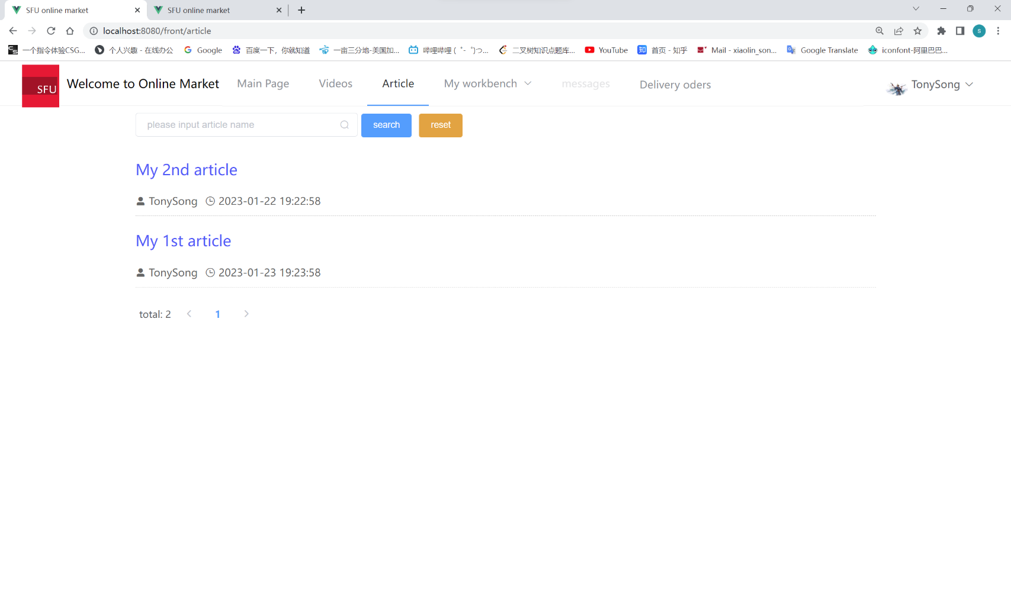

**One of the articles:**

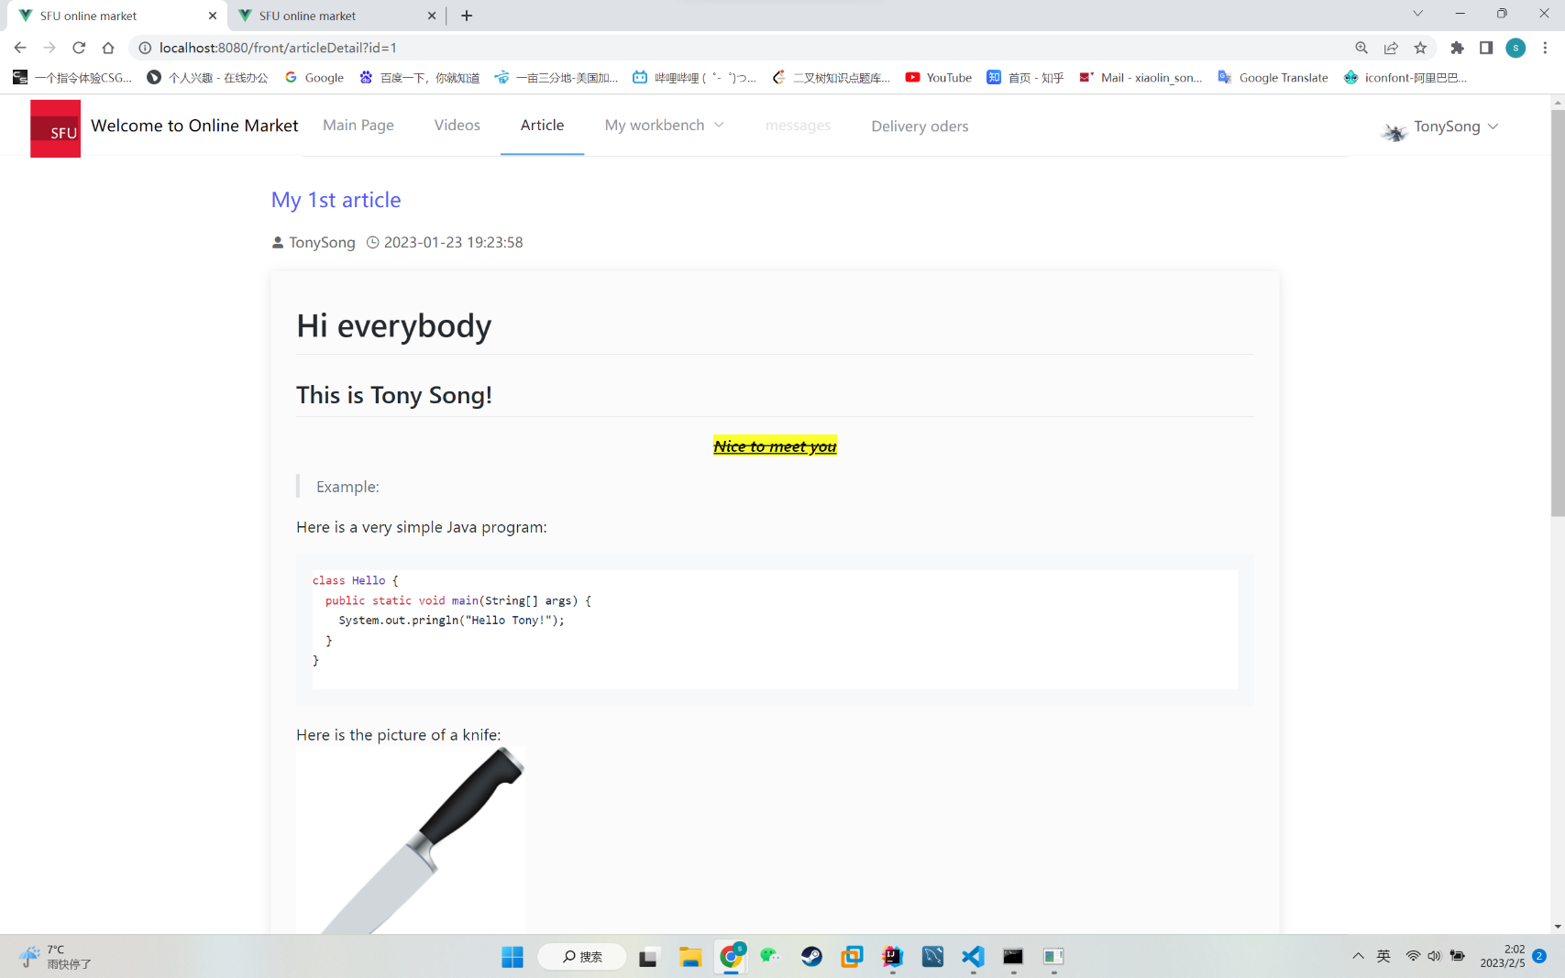

**Use the same procedure to register another user(@Hannah) and make some comments under @TonySong’s article:**

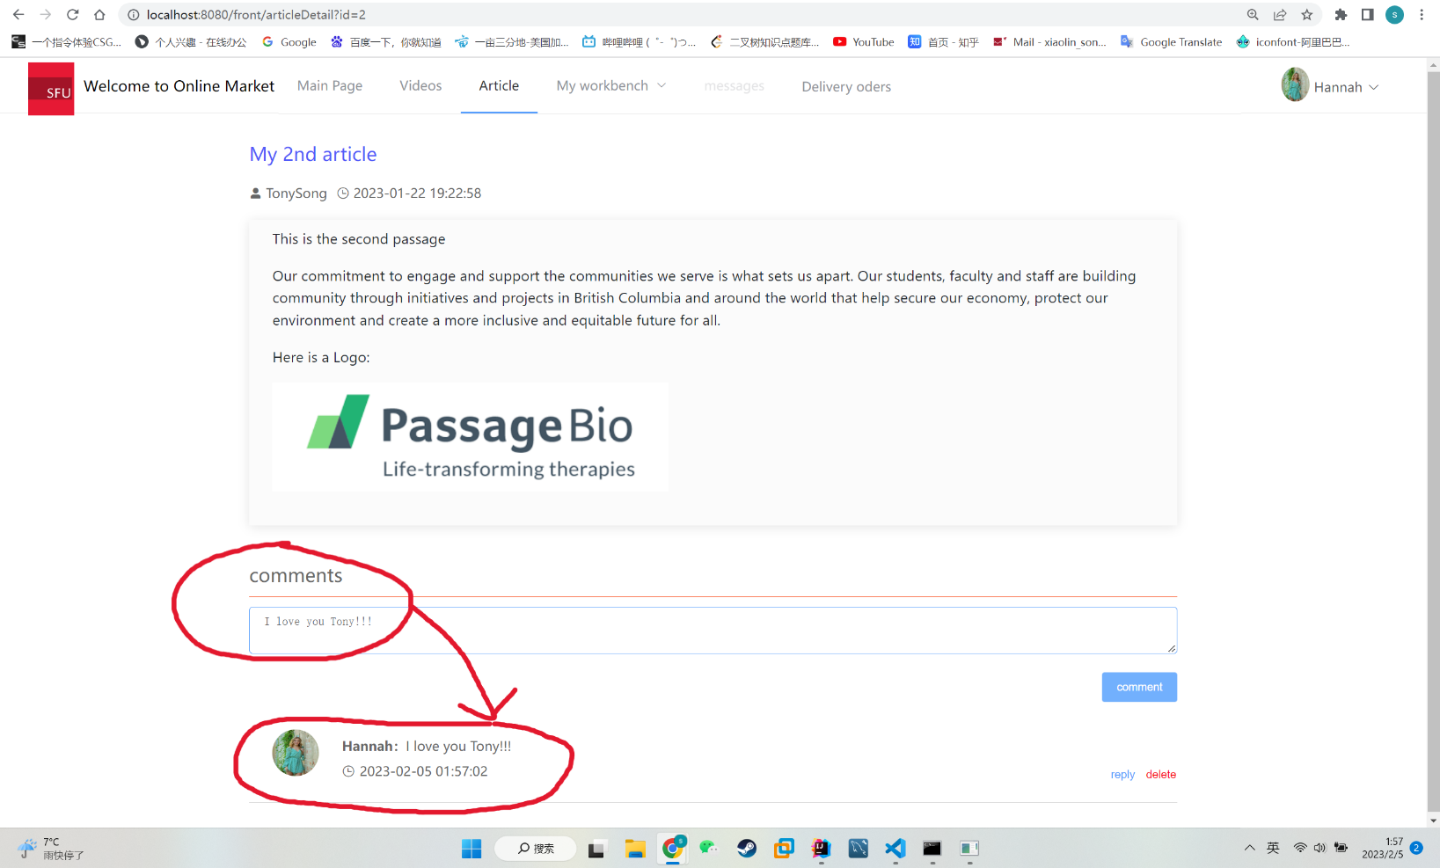

Back to @TonySong and reply to @Hannah:

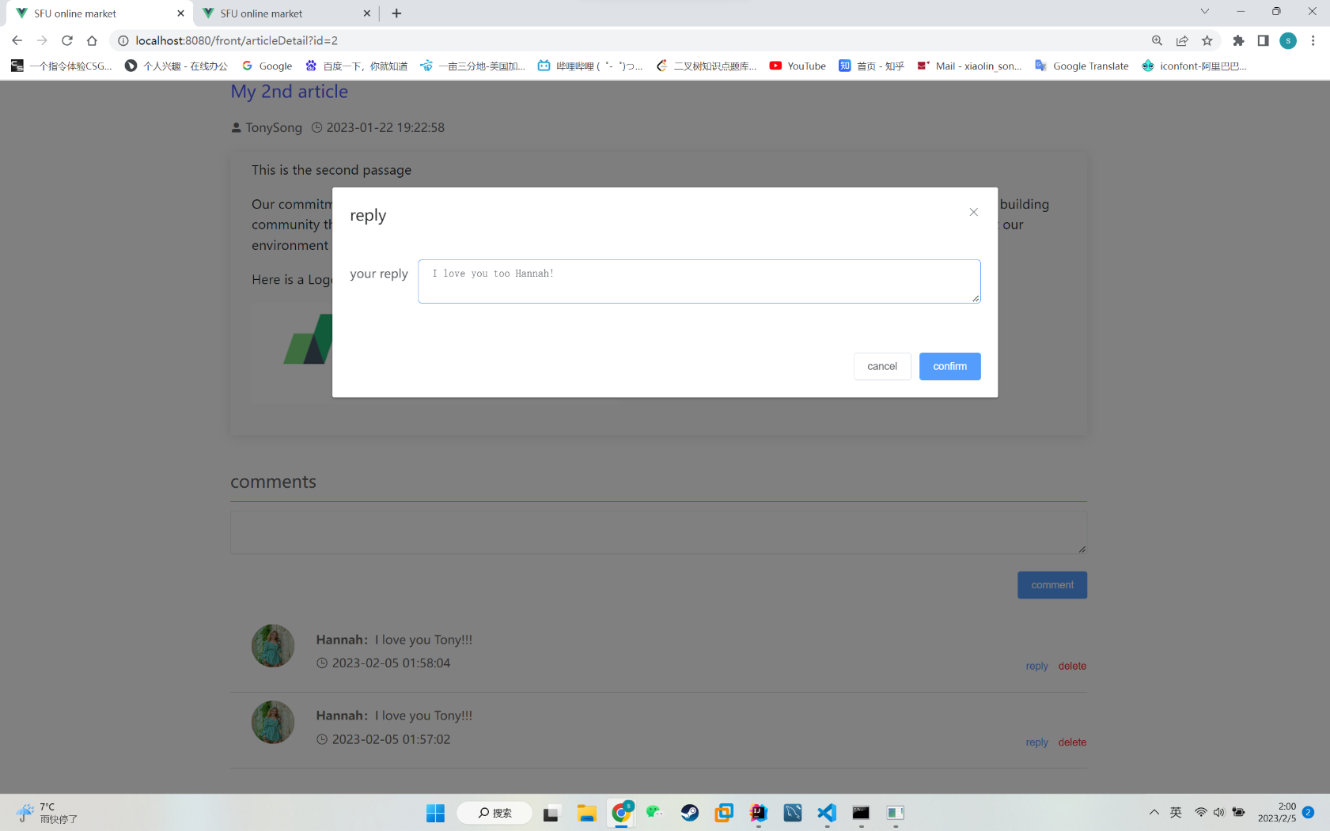

**Reply sent successfully:**

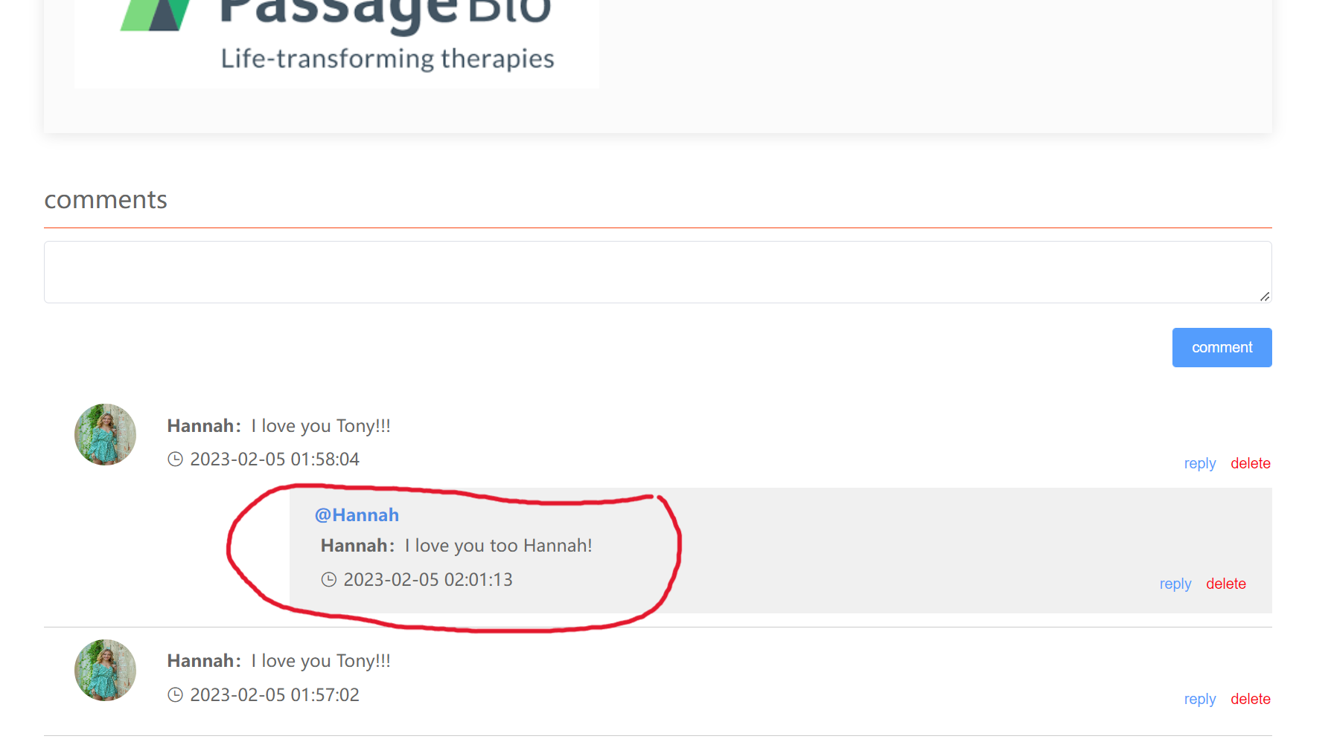

Go to the video menu:

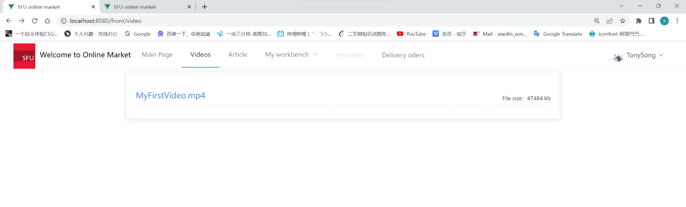

Playing the video:

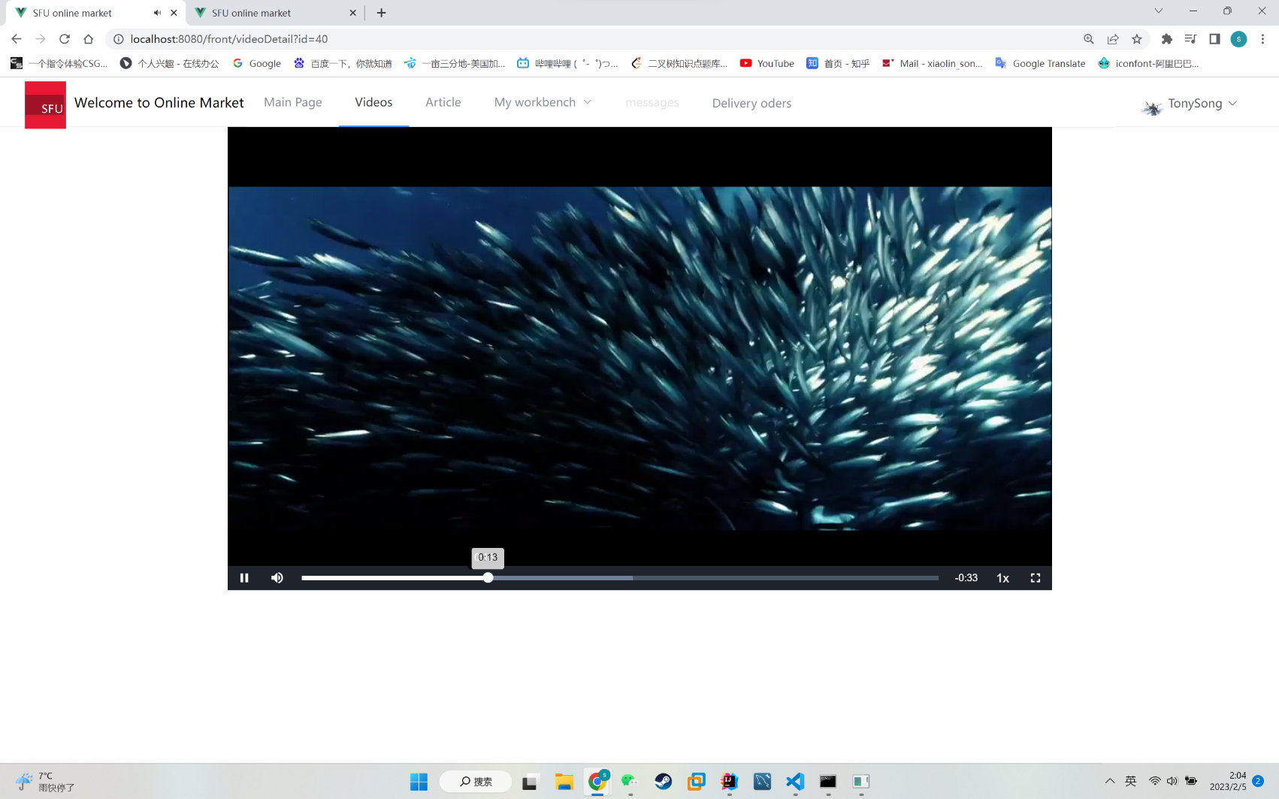

Workbench menu(still haven’t completed its functions):

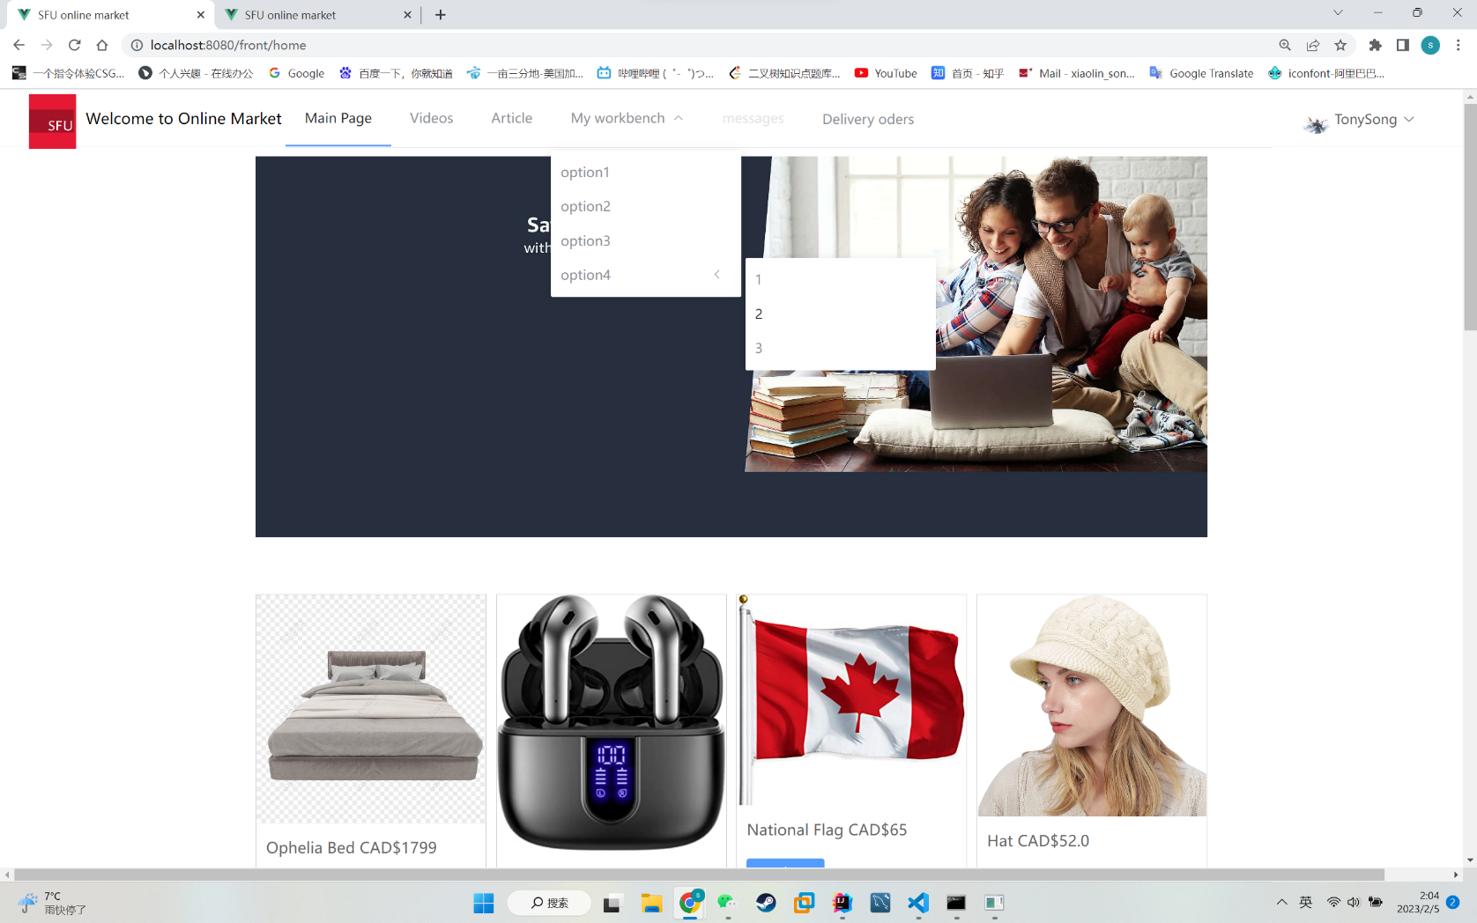

**Click “Delivery orders” and then jump to the UberEat website:**

